Emon

A TRAJECTORY BASED SINGLE CELL ANALYSIS TOOL

**Software Project Lab - III**

**CISTRON  
(A Trajectory Based Single Cell Analysis Tool)**

**Course No: SE – 801**

Submitted by

**Ishrat Jahan Emu**

BSSE 0927

Session: 2016–17

Supervised By

**Dr.Sumon Ahmed**

Assistant Professor

Submitted to

**Software Project Lab – III Coordinators**



Institute of Information Technology (IIT)

University of Dhaka

**Date of Submission**: 05th April 2021

## Letter of Transmittal

April 05,2021

Software Project Lab – III Coordinators

Institute of Information Technology

University of Dhaka.

Dear Sir,

I was assigned to develop an R shiny application named Cistron (A Trajectory Based Single Cell Analysis Tool). I am submitting my report with due respect. I have tried my best for the report.

So, may I therefore, hope that you would and oblige thereby.

Sincerely yours,

_____________

Ishrat Jahan Emu

BSSE 0927

Institute of Information Technology

University of Dhaka

## Document Authentication

This project document has been approved by the following persons.

_____________

__________________

Approved by

Dr. Sumon Ahmed

Assistant Professor

Institute of Information Technology

University of Dhaka

Prepared by

Ishrat Jahan Emu

BSSE 0927

Institute of Information Technology

University of Dhaka

## Acknowledgement

By the grace of Almighty Allah, I have completed my technical report on Cistron (A Trajectory Based Single Cell Analysis Tool).

I am grateful to my supervisor Dr. Sumon Ahmed for his direction throughout the working time.

I am also thankful to the Single Cell Research Lead of The University of Manchester. They helped me a lot by sharing their valuable knowledge with me.

## Abstract

In the field of cellular biology, single-cell analysis is the study of genomics, transcriptomics, proteomics, metabolomics and cell–cell interactions at the single cell level. Being a new technology, sc-rna technology has been established as an important tool in biological analysis. As cell-to-cell variation is a very common and natural property for both healthy and diseased tissues, in most cases single cell RNA analysis provides better outcome than bulk RNA sequencing.

Trajectory inference is a computational technique used in single-cell analysis to determine the pattern of a dynamic process experienced by cells.

Trajectory inference methods are used to infer the developmental dynamics of a continuous biological process such as stem cell differentiation and cancer cell development. Although there are a bunch of trajectory methods, users often face difficulties using the same trajectory method for different datasets. Cistron provides a comparative analysis of Different Trajectory Interface.

Although last year , the world has faced the COVID-19 pandemic situation. There is no doubt that Bioinformatics have to do many things to protect mankind.

This document contains the technical report for the Software Project Lab-III which entitled Cistron (A Trajectory Based Single Cell Analysis Tool). This document provides the overview of the of the scenario-based model, class-based model, and data flow model including the methodology for using Augmented Reality. It also contains the description of tools and technologies used in this application and user manual for this application. Using this document as a guide, we are describing the requirements, necessary diagrams, procedures and working sequence of our project.

Here I will discuss how I will identify the requirements, how to analyze them and how to present a recommended solution for the system.

This will help to make the software according to the demand of the stakeholders

**Table of Contents**

Letter of Transmittal 2

Document Authentication 3

Acknowledgement 4

Abstract 5

CHAPTER 01: INTRODUCTION 9

CHAPTER 02: BACKGROUND STUDIES 10

**2.1 Single CELL RNA SEQUENCING** 10

**2.3** **PRE-PROCESSING THE DATA** 11

**2.4** **TRAJECTORY INTERFACE** 12

CHAPTER-03: PROJECT DESCRIPTION 13

**3.1 INTRODUCTION** 13

**3.2 ELICITING REQUIREMENTS** 13

**3. 3 COLLABORATIVE REQUIREMENTS GATHERING** 13

**3. 4 QUALITY FUNCTION DEPLOYMENT** 13

**3. 5 USAGE SCENARIO** 15

CHAPTER-04: SCENARIO BASED MODELING 16

CHAPTER-05: CLASS BASED MODELING 18

**5.1 FINAL CLASSES** 18

**5.1 CLASS DIAGRAM** 19

CHAPTER-06: ARCHITECTURAL DESIGN 20

CHAPTER-07: PRELIMINARY TEST PLAN 21

**7.1Test Case** 21

CHAPTER-08: METHODOLOGY 22

**8.1 Slingshot** 22

**8.2 TSCAN** 22

**8.3 Monocle** 23

CHAPTER-09: IMPLEMENTATION OVERVIEW 24

**9.1 R Programming Language** 24

**9.2 R Studio** 24

**9.3 R Shiny Framework** 25

**9.4 Electron Packager** 25

CHAPTER-10: USER MANUAL 26

CONCLUSION 41

**Table of Figures**

Figure 1: Single cell sequencing 9

Figure 2:Single cell Data Pre-processing 10

Figure 3:Level 0 use case diagram of Cistron 15

Figure 4: Level 1 use case diagram of Cistron 16

Figure 5: Class diagram of Cistron 18

Figure 6: Architectural Context Diagram 19

Figure 7:Electron Meets Shiny 24

Figure 8: Exe File 25

Figure 9:Home Page of Cistron 26

Figure 10:Projection 27

Figure 11:Gene Expression 28

Figure 12Violin Plot of Sample 28

Figure 13:Highly Expressed Genes 29

Figure 14:First Look PCA 30

Figure 15: Pseudotime 30

Figure 16:TSCAN PCA 31

Figure 17: TSCAN Pseudotime 31

Figure 18: Slingshot PCA 32

Figure 19: Slingshot Pseudotime 32

Figure 20: Feature Selection 33

Figure 21: Monocle UMAP 34

Figure 22: Monocle3 Pseudotime 35

Figure 23: Diffusion Map Component 36

Figure 24: DiffusionMap Pseudotime 36

Figure 25: progenutor marker genes 37

Figure 26: UMAP space with gene expression 37

Figure 27: PatternTest with DiffEnd Test 38

Figure 28: log expression 38

Figure 29: Session Info 39

# **CHAPTER 01: INTRODUCTION**

This document contains the system requirements “Cistron”, a single-cell RNA-sequencing analysis tool. This specification document includes descriptions of the functions and the specifications of the project. In this section, a review of the entire document is provided. The reader would get familiarized with the contents before the further details are described.

Single cell RNA-seq data raises computational challenges in data analysis due to high variability. Bulk RNA-seq technologies have been widely used to study gene expression patterns at population level in the past decade.The advent of single-cell RNA sequencing (scRNA-seq) provides unprecedented opportunities for exploring gene expression profile at the single-cell level. Currently, scRNA-seq has become a favorable choice for studying the key biological questions of cell heterogeneity and the development of early embryos (only include a few number of cells), since bulk RNA-seq mainly reflects the averaged gene expression across thousands of cells.

Trajectory inference is a computational technique used in [single-cell](https://en.wikipedia.org/wiki/Single-cell_transcriptomics) analysis to determine the pattern of a dynamic process experienced by cells.

Trajectory inference methods are used to infer the developmental dynamics of a continuous biological process such as stem cell differentiation and cancer cell development. Although there are a bunch of trajectory methods, users often face difficulties  using the same trajectory method for different datasets. Cistron provides a comparative analysis of Different Trajectory Interface.

Although last year , the world has faced the COVID-19 pandemic situation. There is no doubt that Bioinformatics have to do many things to protect mankind.

# **CHAPTER 02: BACKGROUND STUDIES**

## 

This part of this document contains necessary terms which be helpful to understand the next Usage Scenario and Methodology of this project.

## **2.1 Single CELL RNA SEQUENCING**

Single cell sequencing examines the sequence information from individual cells with optimized next-generation sequencing (NGS) technologies, providing a higher resolution of cellular differences and a better understanding of the function of an individual cell in the context of its microenvironment. These single-cell analyses will allow researchers to uncover new and potentially unexpected biological discoveries relative to traditional profiling methods that assess bulk populations. Single-cell RNA sequencing (scRNA-seq), for example, can reveal complex and rare cell populations, uncover regulatory relationships between genes, and track the trajectories of distinct cell lineages in development.

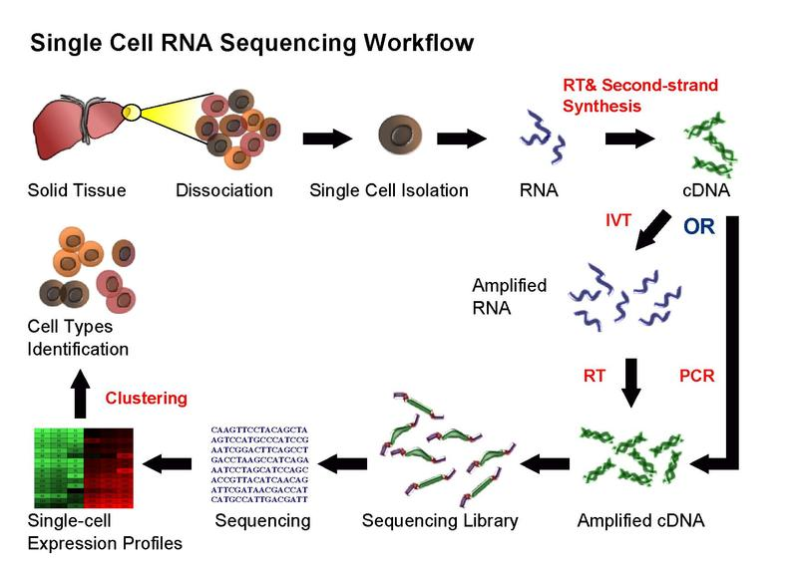

Figure 1: Single cell sequencing

**2.2** **Computational challenges in scRNA-seq**

Although experimental methods for scRNA-seq are increasingly accessible to many laboratories, computational pipelines for handling raw data files remain limited. Some commercial companies provide software tools, such as 10× Genomics and Fluidigm, but this area remains in its infancy, and gold-standard tools have yet to be developed. In the sections below, we will discuss current bioinformatics tools available for the analysis of scRNA-seq data.

### **2.3** **PRE-PROCESSING THE DATA**

Once reads are obtained from well-designed scRNA-seq experiments, quality control (QC) is performed.

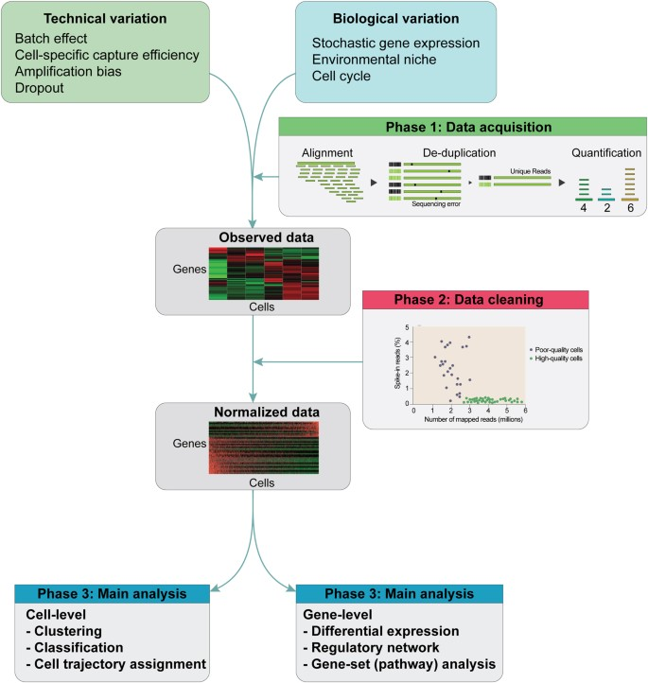

Figure 2:Single cell Data Pre-processing

scRNA-seq data are inherently noisy with confounding factors, such as technical and biological variables. After sequencing, alignment and de-duplication are performed to quantify an initial gene expression profile matrix. Next, normalization is performed with raw expression data using various statistical methods. Additional QC can be performed when using spike-ins by inspecting the mapping ratio to discard low-quality cells. Finally, the normalized matrix is then subjected to main analysis through clustering of cells to identify subtypes. Cell trajectories can be inferred based on these data and by detecting differentially expressed genes between clusters.

### **2.4** **TRAJECTORY INTERFACE**

Trajectory inference methods are used to infer the developmental dynamics of a continuous biological process such as stem cell differentiation and cancer cell development. Most of the current trajectory inference methods infer cell developmental trajectories based on the transcriptome similarity between cells, using single cell RNA-Sequencing (scRNA-Seq) data. These methods are often restricted to certain trajectory structures like trees or cycles, and the directions of the trajectory can only be partly inferred when the root cell is provided.

Pseudotime analyses of single-cell RNA-seq data have become increasingly common. Typically, a latent trajectory corresponding to a biological process of interest – such as differentiation or cell cycle – is discovered. However, relatively little attention has been paid to modelling the differential expression of genes along such trajectories.

The trajectory plot above shows the trajectory followed by olfactory neurons as the develop in mice. Each point is a cell, where are connected into a minimum spanning tree, the core data structure Monocle uses to find the trajectory, shown in black. Each cell’s pseudotime value is measured as the distance along the trajectory from its position back to the beginning.

# **CHAPTER-03: PROJECT DESCRIPTION**

After discussing the inception phase, I need to focus on the Elicitation phase. So, this chapter specifies the Elicitation phase.

## **3.1 INTRODUCTION**

Requirements Elicitation is a part of requirements engineering that is the practice of gathering requirements from the users, customers and other stakeholders. I have faced many difficulties, like understanding the problems, making questions for the stakeholders, problems of scope and volatility. Though it is not easy to gather requirements within a very short time, I have surpassed these problems in an organized and systematic manner.

## **3.2 ELICITING REQUIREMENTS**

Unlike the beginning, Elicitation uses a requirements format that incorporates problem solving, preparation, negotiations and specification components, in which questions were answered. A group of end-users and developers must cooperate in order to generate the demands.

## **3. 3 COLLABORATIVE REQUIREMENTS GATHERING**

There are many different approaches to collaborative requirements gathering. Each approach makes use of a slightly different scenario. We followed the subsequent steps to do it:

I. Meetings were conducted with the research fellows of The University of Manchester. They were questioned about their requirements and expectations from the tool.

II. They were asked about the comparative analysis of Trajectory Interface.

III. At last we selected our final requirement list from these meetings.

## **3. 4 QUALITY FUNCTION DEPLOYMENT**

Quality Function Deployment (QFD) is a technique that translates the needs of the customer into technical requirements for software. It concentrates on maximizing customer satisfaction from the software engineering process. So,I have followed this methodology to identify the requirements for the project. The requirements, which are given below, are identified successfully by the QFD.

#### 

#### **3.4.1 NORMAL REQUIREMENTS**

Normal requirements are generally the objectives and goals that are stated for a product or system during meetings with the stakeholders. The presence of these requirements fulfills stakeholders’ satisfaction. The normal requirements of my project-

* Comparison of the different trajectory inference methods
* Gene Expression
* An easy way to access the data without any bioinformatic expertise.

#### **3.4.2 EXPECTED REQUIREMENTS**

The requirements that are implicit to the system might not be brought up during the meeting because of their fundamental nature. Despite being not explicitly mentioned their presence must be ensured. Otherwise, the product will leave customers dissatisfied. These requirements are called expected requirements and these are stated below.

* Sample and cluster overview panels.
* Tables of most expressed genes and marker genes for samples and clusters.
* Tables of enriched pathways for samples and clusters.
* Different Methods for Trajectory Interface

#### **EXCITING REQUIREMENTS**

* Interactive plot and all plots can be exported to PNG.
* Standalone Application

## **3. 5 USAGE SCENARIO**

Single cell technologies are becoming increasingly important tools in biological analysis. Complementing average measurements on bulk populations of cells, single-cell measurements provide a finer-grained picture of complex biology and unmask heterogeneity that is present in tissues.

Cistron , a trajectory based single cell analysis tool is a standalone application. This tool will take a normalised biological dataset as input. It will show different trajectory interfaces with some common features of single cell technology such as Gene Expression, Enriched Pathway etc. As trajectory interface methods differ for different datasets and users are able to show the different methods result analysis, users can decide the best methods for the particular dataset.

Being a standalone application ,all operating system users can use Cistron without any additional process. Users can export the plot into JPG/PNG format for their further use.

# **CHAPTER-04: SCENARIO BASED MODELING**

For developing our software, we are giving the highest priority to user satisfaction. To identify the requirements to establish meaningful analysis and design model we determine how users want to interact with the system. Thus, our requirements modeling begins with scenario generation in the form of use cases, activity diagrams.

4.1 Use Case

Use case diagrams are usually referred to as behavior diagrams used to describe a set of actions that some system or sub-systems can perform in collaboration with one or more external users of the system.

The first step in writing a Use Case is to define that set of “actors” that will be involved in the story. Actors are the different people that use the system or product within the context of the function and behavior that is to be described. Actors represent the roles that people play as the system operators. Every user has one or more goals when using the system.

4.2 Use Case Diagrams

This section includes use case diagrams and their detailed descriptions of the functions that mentioned in section 4.1.

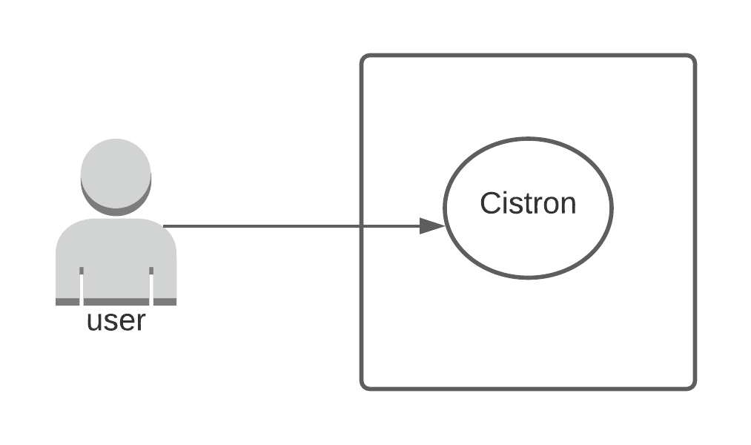

Figure 3:Level 0 use case diagram of Cistron

**Table 1: Information about level 0 use case diagram**

|  |  |
| --- | --- |
| **Name:** | Cistron |
| **ID:** | L-0 |
| **Primary Actor:** | User |
| **Secondary Actor:** | None |

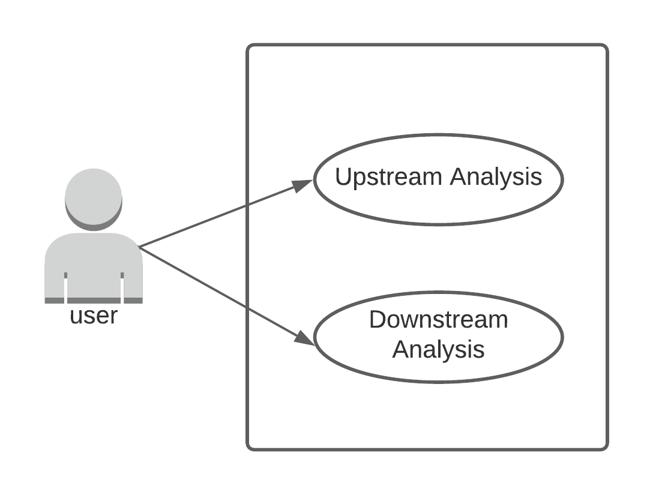

Figure 4: Level 1 use case diagram of Cistron

**Table 2: Information about level 1 use case diagram**

|  |  |
| --- | --- |
| **Name:** | Cistron |
| **ID:** | L-1 |
| **Primary Actor:** | User |
| **Secondary Actor:** | None |

# **CHAPTER-05: CLASS BASED MODELING**

In this chapter, our designed class-based model represents the objects that our “Cistron” will manipulate, the operation that will applied to the objects, relationships between and the collaboration that occur between the classes that are defined.

## **5.1 FINAL CLASSES**

The final classes are identified from the scenario of this project. Those are:

1. UI

2. Server

The class cards of these classes are shown in tables below:

|  |  |
| --- | --- |
| **UI** | |
| Attributes | Methods |
| Dashboard | dashboardSidebar()  dashboardBody()  FluidRow()  plotoutput() |

Table 3: Class card of UI class

|  |  |
| --- | --- |
| **SERVER** | |
| Attributes | Methods |
| Data | Renderplot()  Renderplotly()  Ggplot() |

Table 4: Class card of Server class

## **5.1 CLASS DIAGRAM**

The class diagram of the project “Cistron” is shown below:

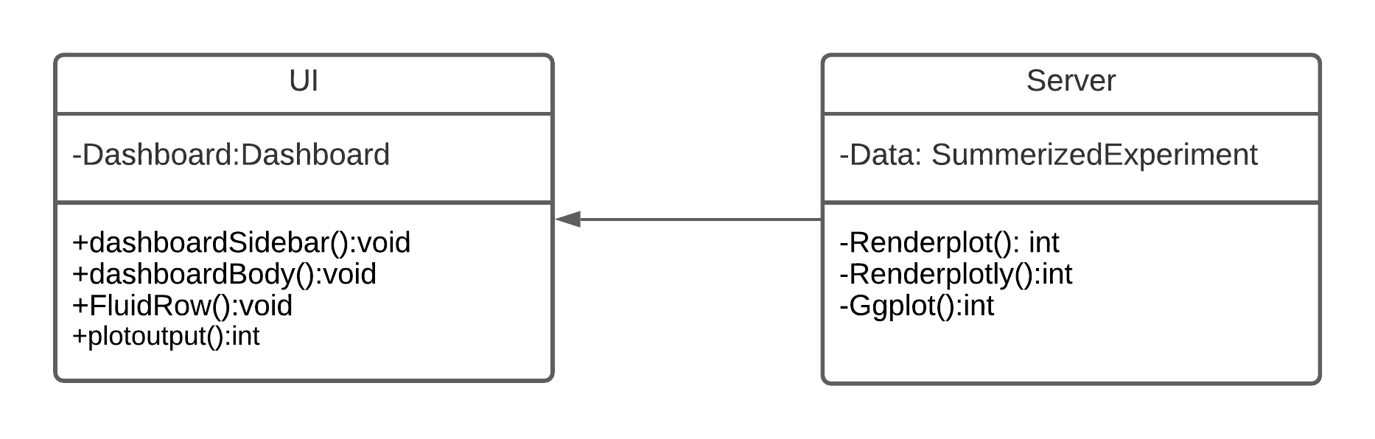

Figure 5: Class diagram of Cistron

# **CHAPTER-06: ARCHITECTURAL DESIGN**

As architectural design begins, the software to be developed must be put into context—that is, the design should define the external entities (other systems, devices, people) that the software interacts with and the nature of the interaction. This information can generally be acquired from the requirements model and all other information gathered during requirements engineering. Once context is modeled and all external software interfaces have been described, you can identify a set of architectural archetypes.

This chapter describes architectural overview and architectural context diagram of the CISTRON (A Trajectory Based Single Cell Analysis Tool).

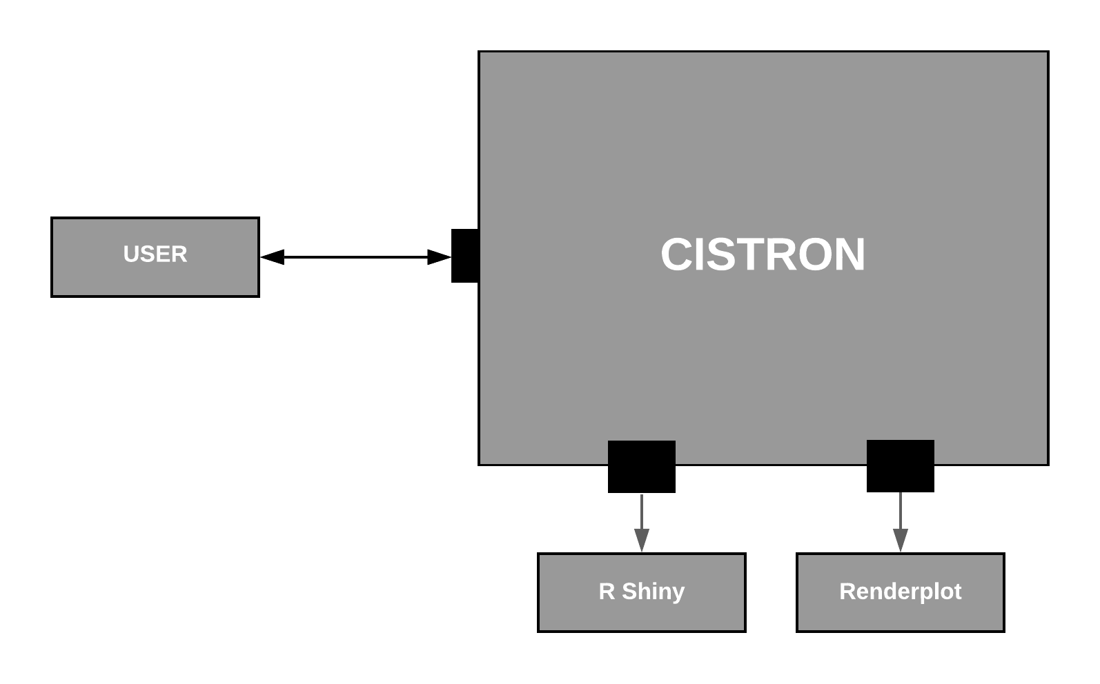

Figure 6: Architectural Context Diagram

User is the only actor that is both producer and consumer of information used or produced by the Cistron (A Trajectory Based Single Cell Analysis Tool).

Finally, R shiny is used by the system for the UI and Server. Renderplot is also used by the system for interactive plot. So they are shown as subordinate system. There is no superordinate or peer-level system.

# **CHAPTER-07: PRELIMINARY TEST PLAN**

I have used black box testing technique to test Cistron (A Trajectory Based Single Cell Analysis Tool

## **7.1Test Case**

Following test cases have been performed on client side.

|  |  |  |  |  |
| --- | --- | --- | --- | --- |
| Test Case ID | Scenario | Steps | Input | Expected output |
| 1 | Have to load Data | Load external File | .xml File | Invalid File |
| 2 | Have to load Data | Load external File | RDS File | Successfully Load |
| 3 | Have to load Data | Load external File | H5 File | Successfully Load |
| 4 | Check Trajectory Interface | Load the Data and Click on different Trajectory Methods | RDS or H5 File | Show the plot |
| 5 | Check Downstream Analysis | Load the Data and Click on different Downstream Analysis Option | RDS or H5 File | Show the plot |

# **CHAPTER-08: METHODOLOGY**

In many situations, one is studying a process where cells change continuously. This includes, for example, many differentiation processes taking place during development: following a stimulus, cells will change from one cell-type to another. Ideally, we would like to monitor the expression levels of an individual cell over time. Unfortunately, such monitoring is not possible with scRNA-seq since the cell is lysed (destroyed) when the RNA is extracted.

Instead, we must sample at multiple time-points and obtain snapshots of the gene expression profiles. Since some of the cells will proceed faster along the differentiation than others, each snapshot may contain cells at varying points along the developmental progression. We use statistical methods to order the cells along one or more trajectories which represent the underlying developmental trajectories, this ordering is referred to as “pseudotime”.

Using single-cell -omics data, it is now possible to computationally order cells along trajectories, allowing the unbiased study of cellular dynamic processes. Since 2014, more than 50 trajectory inference methods have been developed, each with its own set of methodological characteristics. As a result, choosing a method to infer trajectories is often challenging, since a comprehensive assessment of the performance and robustness of each method is still lacking.

Some important Trajectory Interface Methods are described below-

## **8.1 Slingshot**

Slingshot is a tool for the identification of developmental trajectories in single-cell RNA-seq (scRNA-seq) data. The Slingshot algorithm can use prior knowledge via supervised graph construction.

Provides functions for inferring continuous, branching lineage structures in low-dimensional data. Slingshot was designed to model developmental trajectories in single-cell RNA sequencing data and serve as a component in an analysis pipeline after dimensionality reduction and clustering. It is flexible enough to handle arbitrarily many branching events and allows for the incorporation of prior knowledge through supervised graph construction.

## **8.2 TSCAN**

When analyzing single-cell RNA-seq data, constructing a pseudo-temporal path to order cells based on the gradual transition of their transcriptomes is a useful way to study gene expression dynamics in a heterogeneous cell population. Currently, a limited number of computational tools are available for this task, and quantitative methods for comparing different tools are lacking. Tools for Single Cell Analysis (TSCAN) is a software tool developed to better support in silico pseudo-Time reconstruction in Single-Cell RNA-seq ANalysis.

TSCAN uses a cluster-based minimum spanning tree (MST) approach to order cells. Cells are first grouped into clusters and an MST is then constructed to connect cluster centers. Pseudo-time is obtained by projecting each cell onto the tree, and the ordered sequence of cells can be used to study dynamic changes of gene expression along the pseudo-time. Clustering cells before MST construction reduces the complexity of the tree space. This often leads to improved cell ordering. It also allows users to conveniently adjust the ordering based on prior knowledge.

## **8.3 Monocle**

Monocle introduced the strategy of using RNA-Seq for single-cell trajectory analysis. Rather than purifying cells into discrete states experimentally, Monocle uses an algorithm to learn the sequence of gene expression changes each cell must go through as part of a dynamic biological process. Once it has learned the overall "trajectory" of gene expression changes, Monocle can place each cell at its proper position in the trajectory.

If there are multiple outcomes for the process, Monocle will reconstruct a "branched" trajectory. These branches correspond to cellular "decisions", and Monocle provides powerful tools for identifying the genes affected by them and involved in making them. You can see how to analyze branches in the section Analyzing branches in single-cell trajectories .

# **CHAPTER-09: IMPLEMENTATION OVERVIEW**

CISTRON A Trajectory Based Single Cell Analysis Tool A trajectory based single cell analysis tool is a standalone application. This tool will take a normalised biological dataset as input.

It will show different trajectory interfaces with some common features of single cell technology Being a standalone application , all operating system users can use Cistron without any additional process.

Github Link- <https://github.com/ishrat98/SPL-3>

To build the system I have used some technical terms and features. These terms, features and their constraints are explained in the following.

## **9.1 R Programming Language**

R is one of the most widely-used and powerful programming languages in bioinformatics. R especially shines where a variety of statistical tools are required (e.g. RNA-Seq, population genomics, etc.) and in the generation of publication-quality graphs and figures. R can handle large data with a large number of columns and rows without compromising the data.

In life sciences especially in bioinformatics R has been used frequently. Many data analysis algorithms or methods are available in R which was developed by scientific researchers all around the globe. Simple hypothesis tests, like t-test can be used to find the difference in sample data or complex field data can be analyzed using ANOVA which will give the p-value along with other statistics.

In biological science co-expression networks between genes using their expression can reveal many interactions pathways which can give insight into the function of genes altogether. In such cases, correlation networks or weighted correlation networks are very helpful. These networks and co-expression can easily be drawn using R. Apart from simple analyses R can be used for NGS analyses. Few of examples include analysis of RNA-Seq, ChIP-Seq, Wole Genome Bisulfite Sequencing, small RNA-seq and many more. Using the Bioconductor package of R all these analyses can be done on a local machine.

## **9.2 R Studio**

RStudio is an integrated development environment for R, a programming language for statistical computing and graphics. It is available in two formats: RStudio Desktop is a regular desktop application while RStudio Server runs on a remote server and allows accessing RStudio using a web browser.

Data science is impactful, creative work. Having the right tools enables data insights RStudio makes it easier and better. RStudio IDE makes it easy to combine R and Python in a single data science project.

## **9.3 R Shiny Framework**

Shiny is an open source R package that provides an elegant and powerful web framework for building web applications using R. Shiny helps you turn your analyses into interactive web applications without requiring HTML, CSS, or JavaScript knowledge.

Shiny is an R package that makes it easy to build interactive web applications (apps) straight from R. Shiny will also make the app interactive and user friendly. For example renderplotly() and renderTable() makes the application interactive.

## **9.4 Electron Packager**

There are a few different options for packaging Shiny apps into standalone desktop applications. The one I will give a “how-to” on is the method championed by Columbus Collaboratory .

It will make portable versions for all operating systems. So any user of any operating system can easily run the app without any pre-requirements.

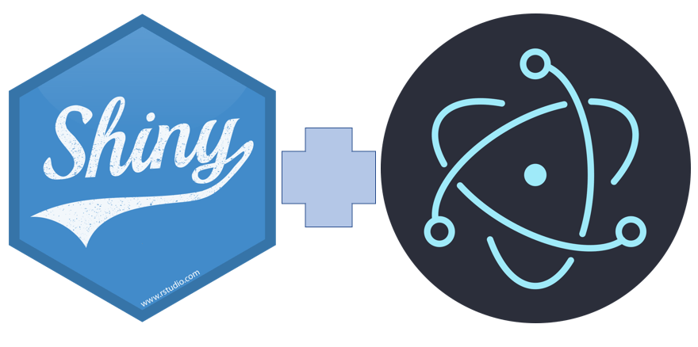

Figure 7:Electron Meets Shiny

# **CHAPTER-10: USER MANUAL**

Cistron is a standalone application. To use this application , users don’t have to install any other programs. Users just need to double click the executable file.

**Exe File:**

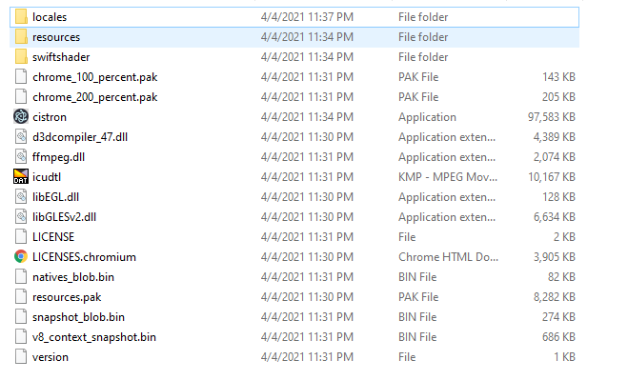

Figure 8: Exe File

**Home Page:**

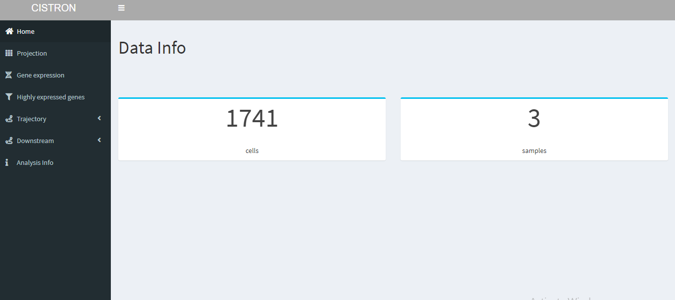

Figure 9:Home Page of Cistron

**Projection:**

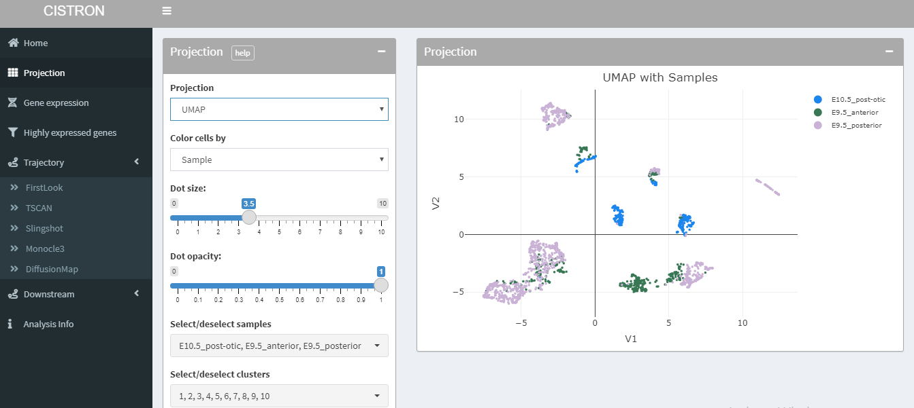

Figure 10:Projection

**Gene Expression:**

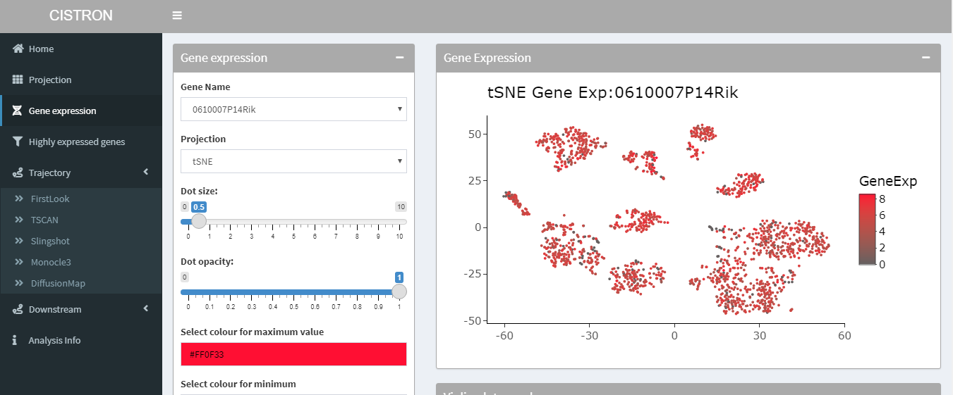

Figure 11:Gene Expression

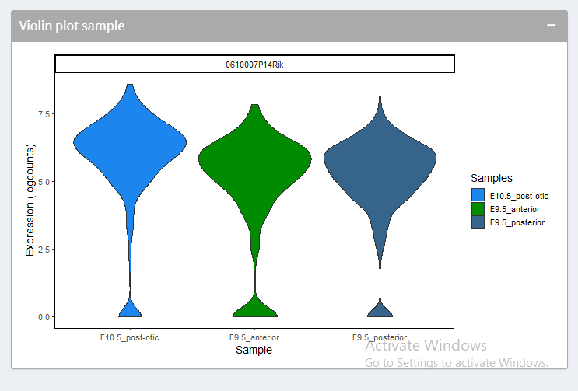

Figure 12Violin Plot of Sample

**Highly Expressed Genes:**

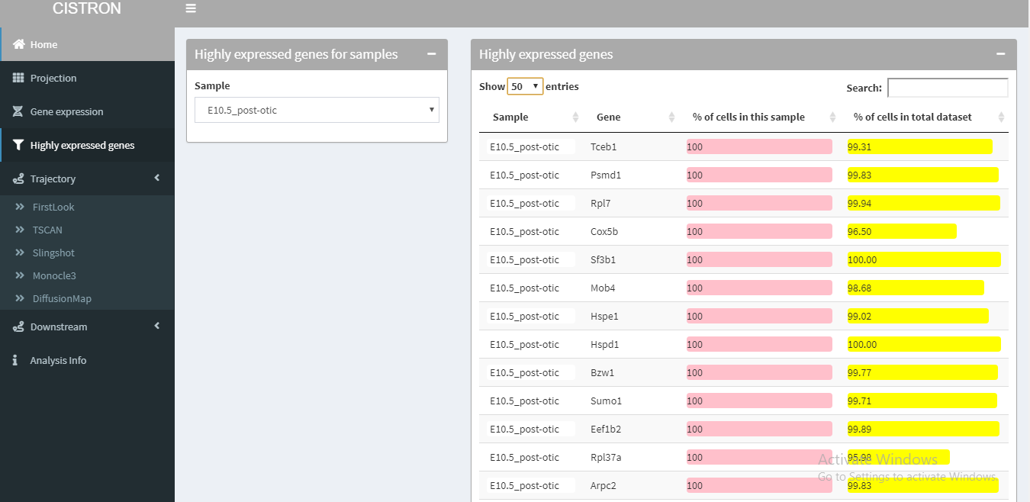

Figure 13:Highly Expressed Genes

**Trajectory Interface**

**First Look :**

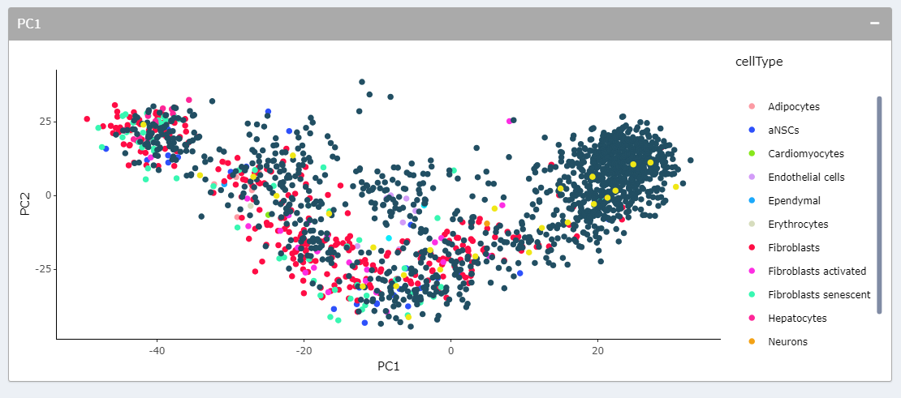

Figure 14:First Look PCA

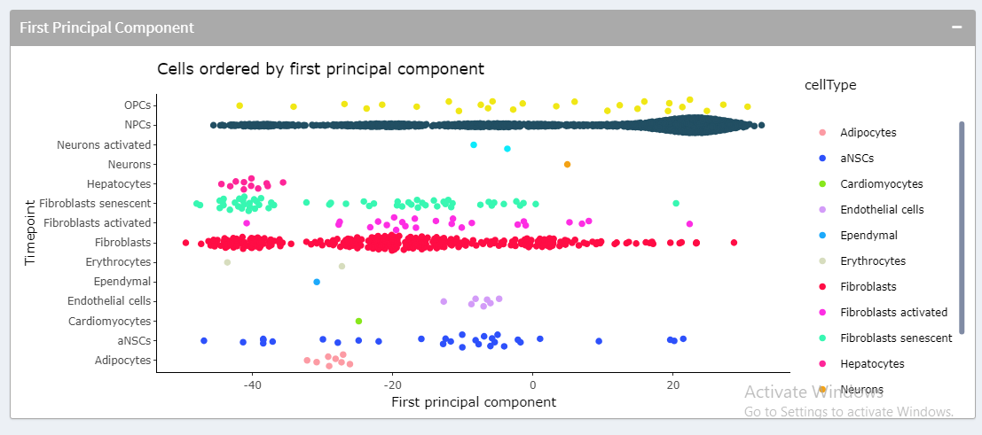

Figure 15: Pseudotime

**TSCAN:**

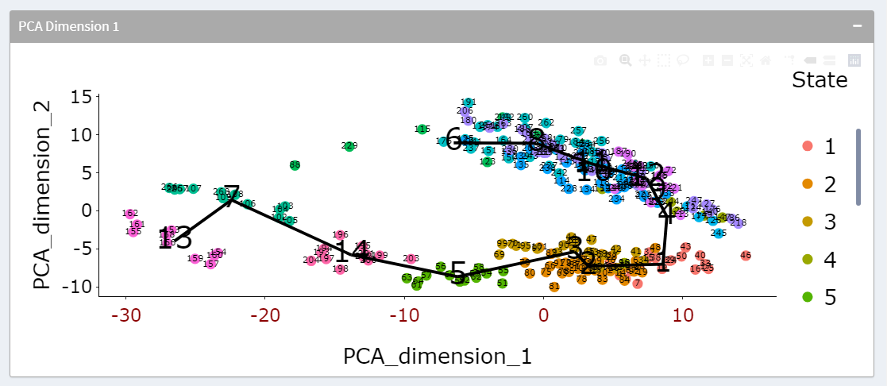

Figure 16:TSCAN PCA

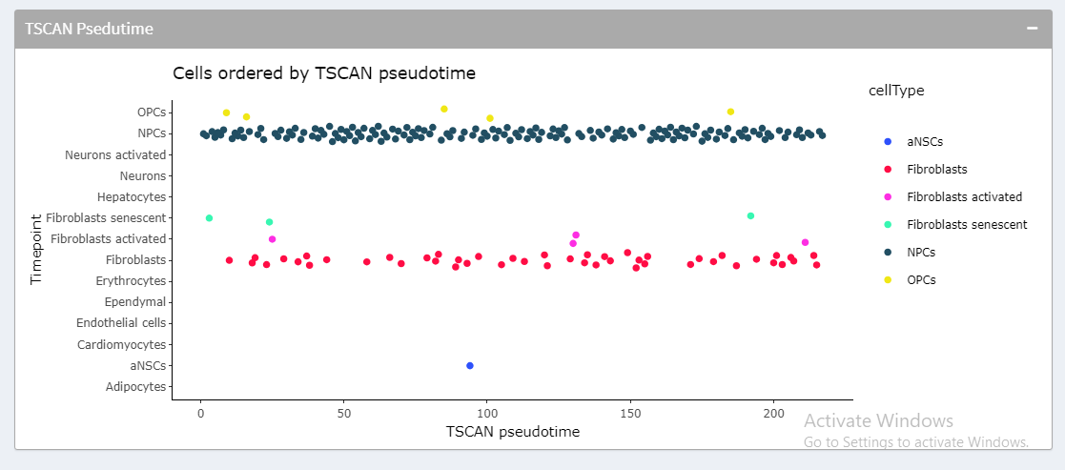

Figure 17: TSCAN Pseudotime

**Slingshot:**

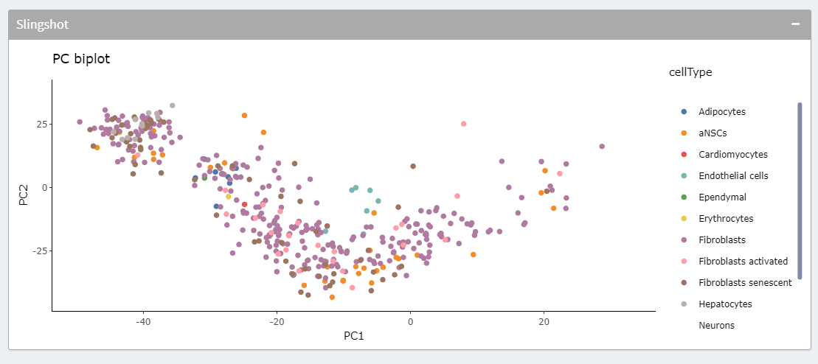

Figure 18: Slingshot PCA

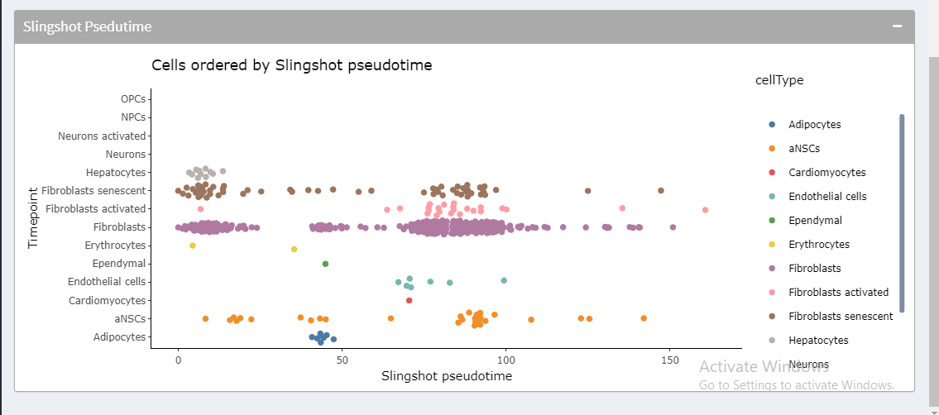

Figure 19: Slingshot Pseudotime

**Monocle3**

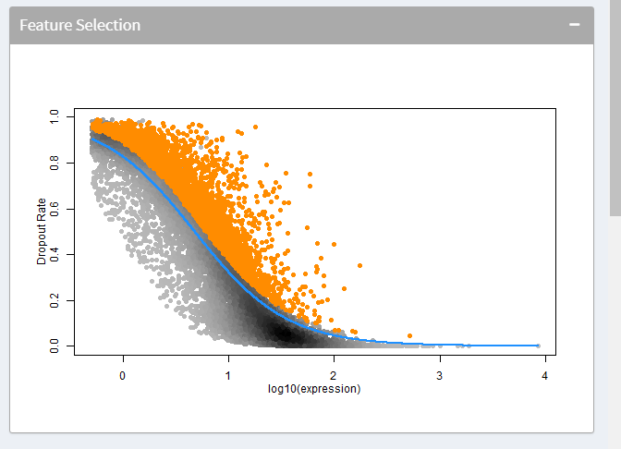

Figure 20: Feature Selection

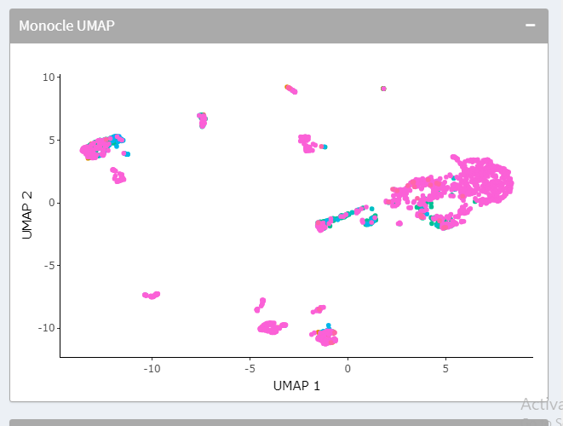

Figure 21: Monocle UMAP

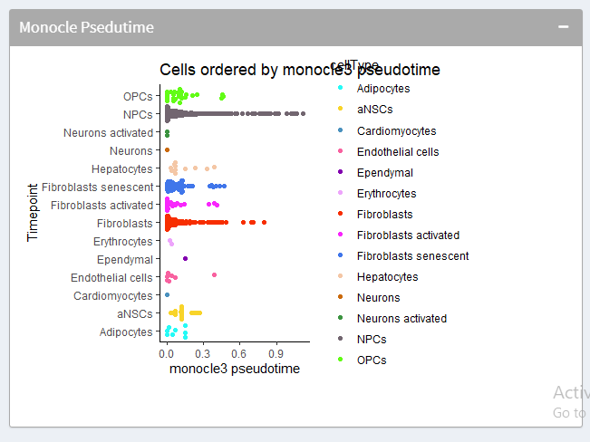

Figure 22: Monocle3 Pseudotime

**Diffusion Map:**

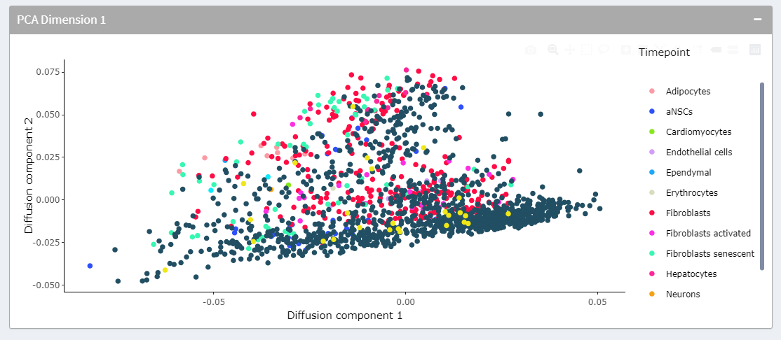

Figure 23: Diffusion Map Component

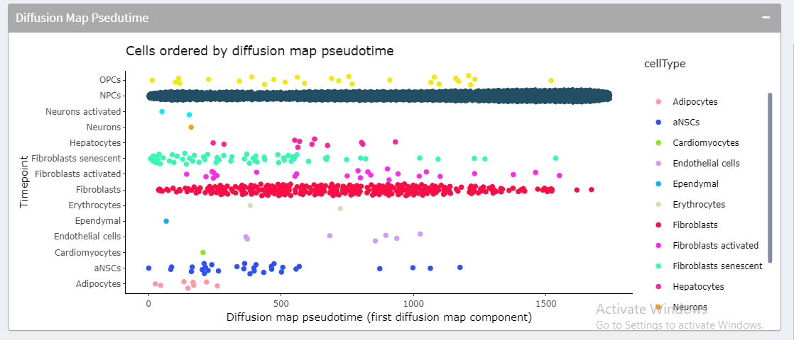

Figure 24: DiffusionMap Pseudotime

**Marker Genes:**

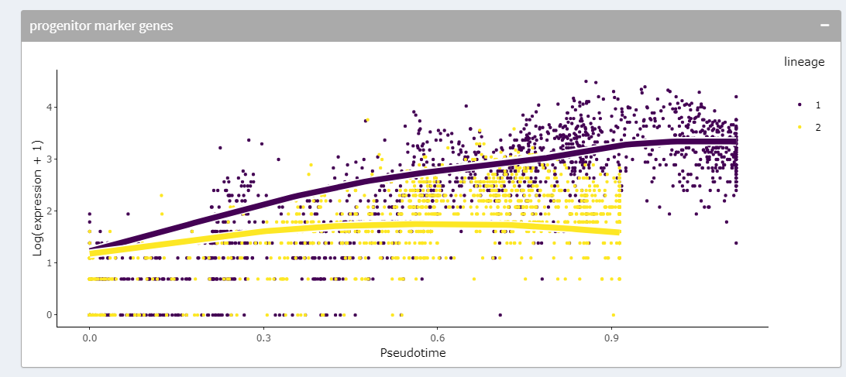

Figure 25: progenutor marker genes

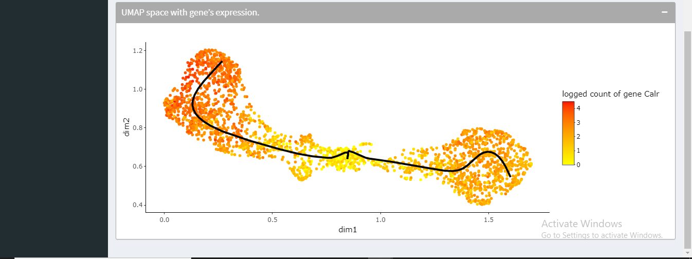

Figure 26: UMAP space with gene expression

**PatternTest with DiffEnd Test:**

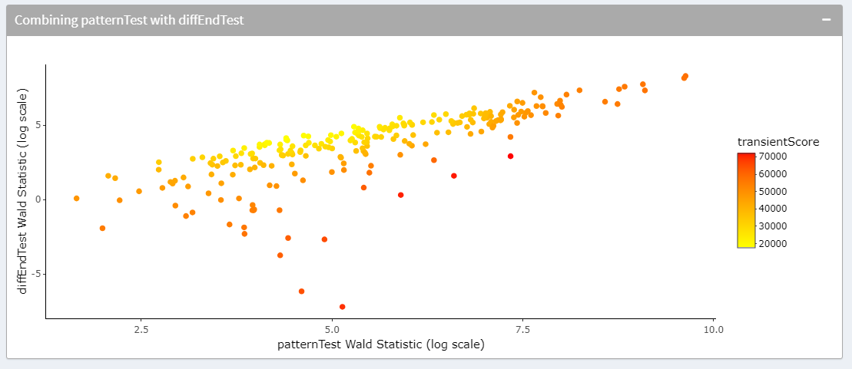

Figure 27: PatternTest with DiffEnd Test

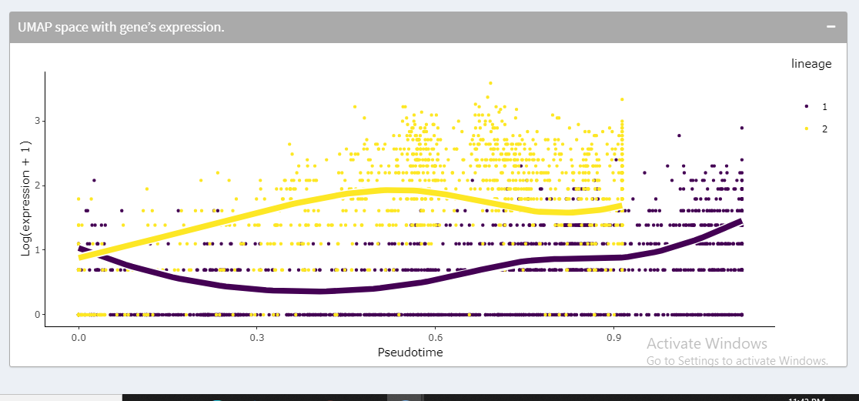

Figure 28: log expression

**Analysis Info:**

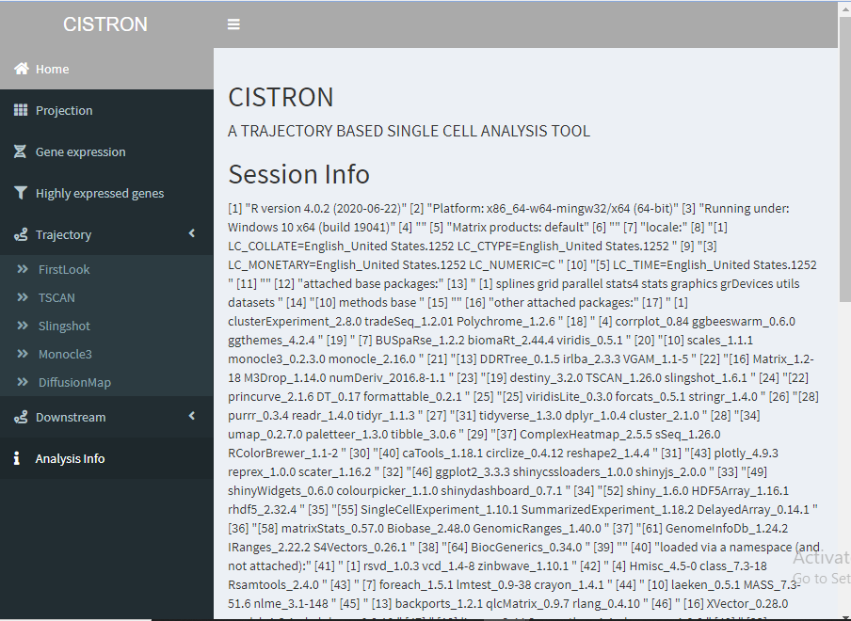

Figure 29: Session Info

# **CONCLUSION**

It was so much challenging to prepare a final report for the first time. I think that this report has been written in an easy-to-read way as well as with full information required to have a good concept over the idea. The reader of should easily understand the information of the report.

**References**

1. Saelens, Wouter, et al. "A comparison of single-cell trajectory inference methods." Nature

biotechnology 37.5 (2019): 547.

2. Wolf, F. Alexander, et al. "PAGA: graph abstraction reconciles clustering with trajectory inference

through a topology preserving map of single cells." Genome biology 20.1 (2019): 59.

3. Street, Kelly, et al. "Slingshot: cell lineage and pseudotime inference for single-cell

transcriptomics." BMC genomics 19.1 (2018): 477.

4. Trapnell, Cole, Davide Cacchiarelli, and Xiaojie Qiu. "Monocle: Cell counting, differential

expression, and trajectory analysis for single-cell RNA-Seq experiments." (2019): 10.

5. La Manno, Gioele, et al. "RNA velocity of single cells." Nature 560.7719 (2018): 494.